# A (Virtual) World of Your Own

In this lab exercise you will run a virtual world on a desktop PC, then launch a 3D client to connect to the virtual world. After exploring, you will then have the opportunity to either let another user enter your world – or to enter the world run by another user.

The virtual world you’ll be running will be a virtual Scotland, running on the OpenSim platform.

## 1 Get a Copy of UWS-OpenSim and Imprudence Viewer

UWS-OpenSim & Imprudence viewer will be made available on the network – the URLs will be posted on Moodle. You can run these apps from USB or from C:/Temp. Performance may be higher on the C: drive. On a small USB memory stick, you may induce memory wear in trying to run both apps from the memory stick – but should be fine on larger capacity devices. If required, copy the apps to C:/Temp before proceeding to the next step.

## 2 Startup OpenSim & Login

Run OpenSim: **<drive:\path>\UWS-opensim-0.7.0.2-bin\bin\opensim.exe** When run, a console window will appear with status messages scrolling past detailing the steps taken as OpenSim starts up. (If you have problems starting OpenSim, you may need to use **OpenSim.32BitLaunch.exe** instead.)

Allow a couple of minutes for the main services to initialise before starting Imprudence. Start Imprudence from **<drive:\path>\soas_viewer\Imprudence\imprudence.exe** . To login, select **localhost** from the Grid selection box, and enter the user name **Admin User** in the first and last name text boxes. The password is “**123456**”. If you have problems logging in, you may need to use the ‘grid manager’ tab to change the login URI to <http://127.0.0.1:9000/>

Press login and wait for things to get going...

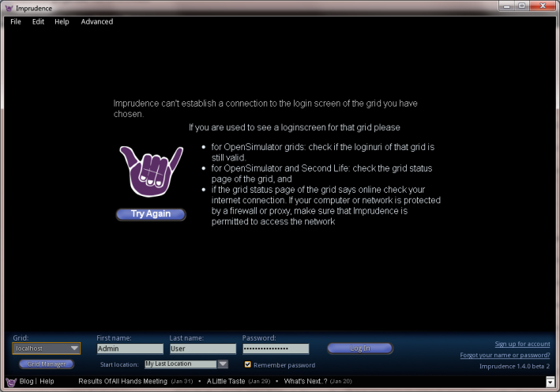

## Welcome to Your World

You will appear near some buildings. Your avatar is ‘Ruth’ – the default OpenSim avatar. It is possible to customise your avatar – but leave that for now.

First you will want to move around the world. You can move using the arrow keys, with page-up allowing you to jump and fly, and page-down allowing you to fly down and crouch. On screen controls (see below) allow you to use the mouse to control your avatar’s movements.

More detailed instructions on controlling your avatar and interacting with the world can be found in the Second Life QuickStart Instructions on Blackboard (pages 2-3).

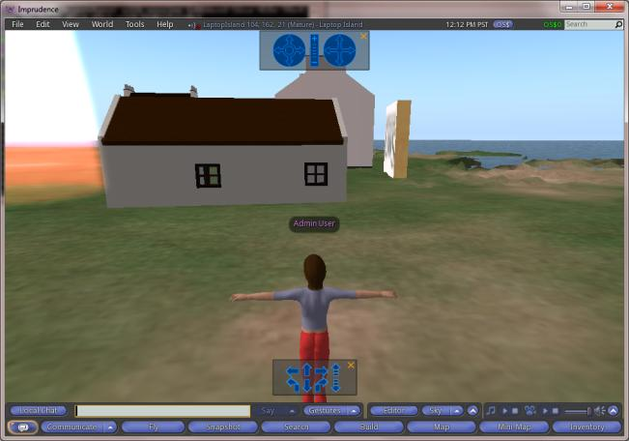

## Explore Some Mysterious Boxes

Between the buildings are a line of three boxes (see below). Click on each box in turn, and see what happens.

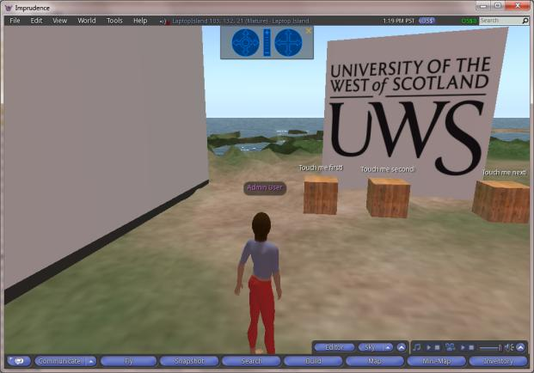

After trying all three boxes, time to examine the scripts inside. If you right-click on the ‘Click me first!’ box, the pie-menu (see below) will appear. Select ‘Edit’ from this menu.

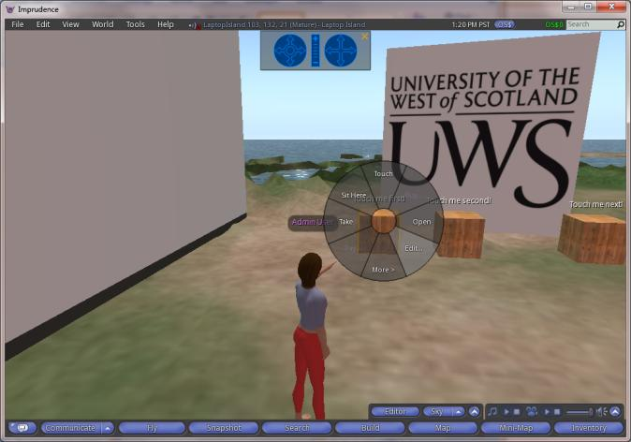

The Object Editor dialog will now appear (dialog on the left in the image below). From this dialog you can edit most of the objects properties. Choose the **Contents** tab, and double-click on the script listed in the contents. This will open in a script editor (see below). You can now examine and edit the script in the object. Try changing the message in the floating text that appears over the box, or the messages it gives when touched.

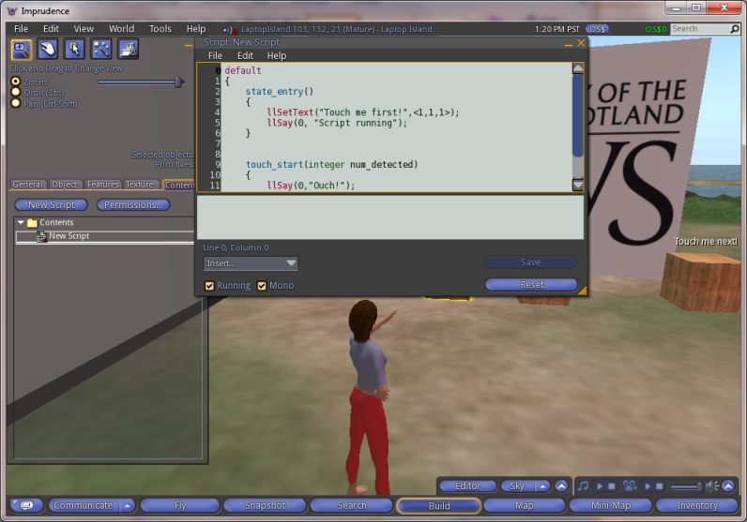

From a brief examination of the script, you should be able to see that the scripting language is event driven. The language used is LSL (Linden Script Language), and this is documented in great detail online at e.g.:

<http://wiki.secondlife.com/wiki/LSL_Portal>  
<http://lslwiki.net/lslwiki/wakka.php?wakka=HomePage>

There is even a simple script generator online at <http://www.3greeneggs.com/autoscript/> - and many 3rd party sites have sample scripts that can be downloaded.

LSL is a feature rich scripting language – that allows the creation of simple bots, vehicles, interactive displays, games, etc., and which allows the creation of objects that interact with external web-servers via HTTP requests. It is also a scripting language and environment with a number of quirks.

## Building a Cube

The basic building blocks in OpenSim (and Second Life) are simple 3D geometric primitives – or *prims*. It is also possible, depending on server and client versions, to import 3D meshes from standard modelling packages – but the in-world building tools are particularly well suited to for builders and rapid prototyping.

Find an empty patch of ground, and right-click on the ground to open the pie menu (below). Select the **build** option.

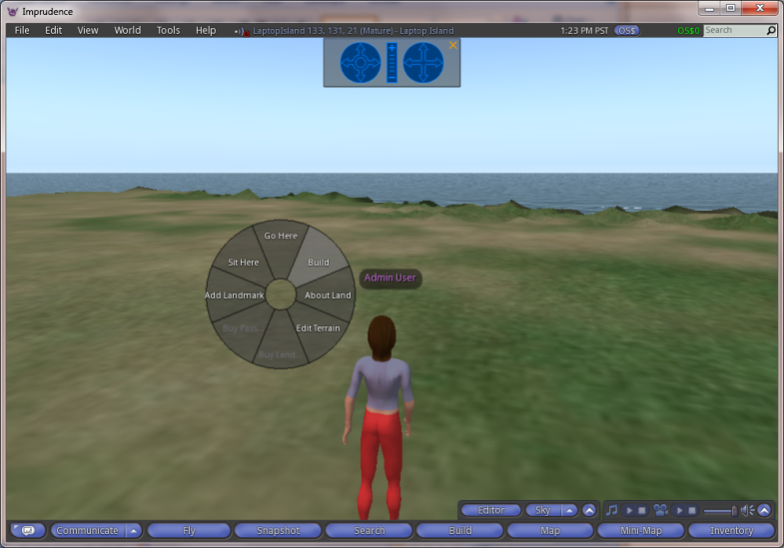

The build menu will appear. The **create** option will be selected, and the current prim selection will be a cube. Click again on the ground and a new cube will appear (see below).

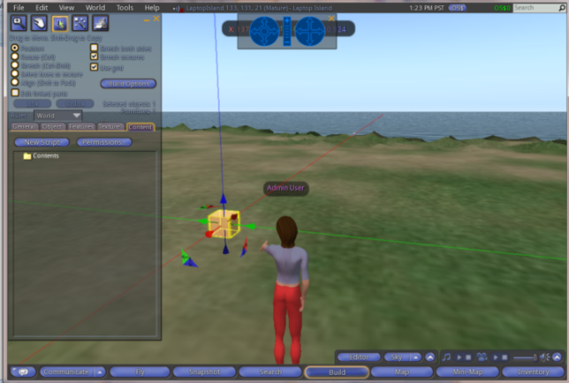

You can use the Object tab on the build menu to manipulate the cube, and there are a range of shortcuts available using the mouse and ctrl, alt and shift keys. Play around with the cube and see how you can reshape and distort it.

There are **many** online guides and videos on building in SL, which equally apply to using the building tools in OpenSim. The following are simply to get you started:

<http://www.youtube.com/watch?v=szAbCGbqYEI>   
<http://www.youtube.com/watch?v=zX6gvol-zIU>  
Note: You can link multiple selected primitives into one object with CTRL-L, and un-link an object with CTRL-SHIFT-L.

You can create some very detailed models using these simple tools, e.g.: <http://www.youtube.com/watch?v=zX6gvol-zIU>

## Explore Your World

There are more things waiting to be found in your world – go and explore.

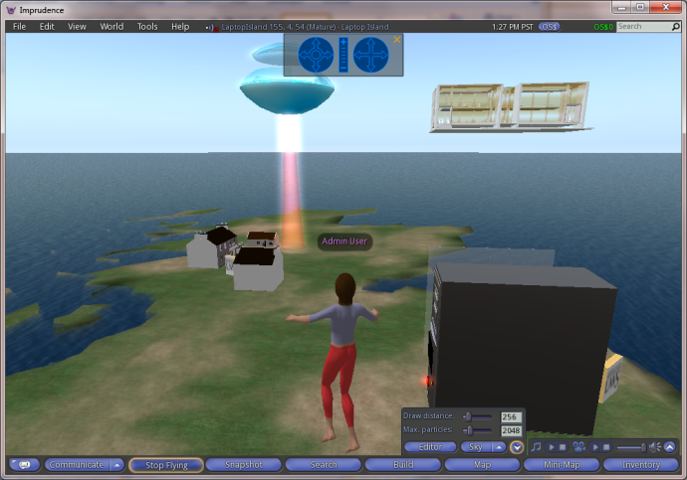

## Multi-User Worlds

So far, your virtual world has been quite lonely. Now is a chance to invite another user into your world – or to join someone else’s world.

### Create a new user account for your world

In the OpenSim console window, type “**create user**”. You will be prompted for a user name and password. Invite someone to log into your world by passing them their user details and the IP address of your machine. *This has not been tested to see if it works cross campus – if you can, try and invite a student from another campus to visit your world, or visit the world of a user from another campus.*

### Join Another user’s world

Close Imprudence, and type “quit” in your OpenSim console window to close your current client and world. Re-start Imprudence, and click on the **Grid Manager** button. In the dialog that appears (see below) create a new grid entry – name it according to the IP address of the machine that you will be connecting to. Fill in the user details you have been given, and set the login URI to use the IP address you have been given and port 9000 – e.g. replace the IP address in <http://127.0.0.1:9000/> with the correct address for the machine you will be connecting to.

Try and login. If this works (it hasn’t been tested in the labs yet!) you should appear in a virtual world much like the one you were running previously – but this time you will be sharing a world with another user (or users).

Try using text-chat and sending IMs to other users.

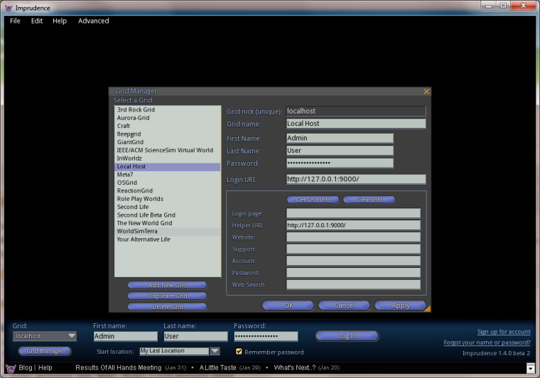

# Your Homework

There are two options for homework, you should spend about two hours on either option:

## Option A: Explore Second Life

Create an account on Second Life, and download the client at home. From the online destination guide, pick any two destinations from two different categories of your choice. Explore these two destinations, chat to some other users. Take a screenshot from each destination – and post to the discussion forum on Blackboard along with a paragraph or two about your adventures.

## Option B: Building and Scripting in OpenSim

Using your OpenSim world, practice building and scripting. Take screenshots of your creations – and post to the discussion forum on Moodle along with a paragraph or two about your achievements.

## Bonus Option:

OpenSim has been updated to version 7.5 since this release, all in one packages such as Diva D2 (<http://metaverseink.com/Downloads.html>) have been created to simplify the creation of new OpenSim multi-user worlds, and more recent viewers such as Firestorm (<http://www.firestormviewer.org/> ) have been released. You may try to see if you can use the OAR archive format to recreate the virtual Scotland in the most recent version of OpenSim, or set up a world on a USB stick using Sim-On-a-Stick (<http://simonastick.com/>)

If you have access to your own web-server, you may try to set up your own OpenSim world (note that access from University may not be possible due to firewall restrictions – but it should be possible to lift these on request.)